Apocalypse Food Prep – mini project

Step 1: We preview the data and click on Transform Data so we can move to PowerQuery Editor first before building any visualisation.

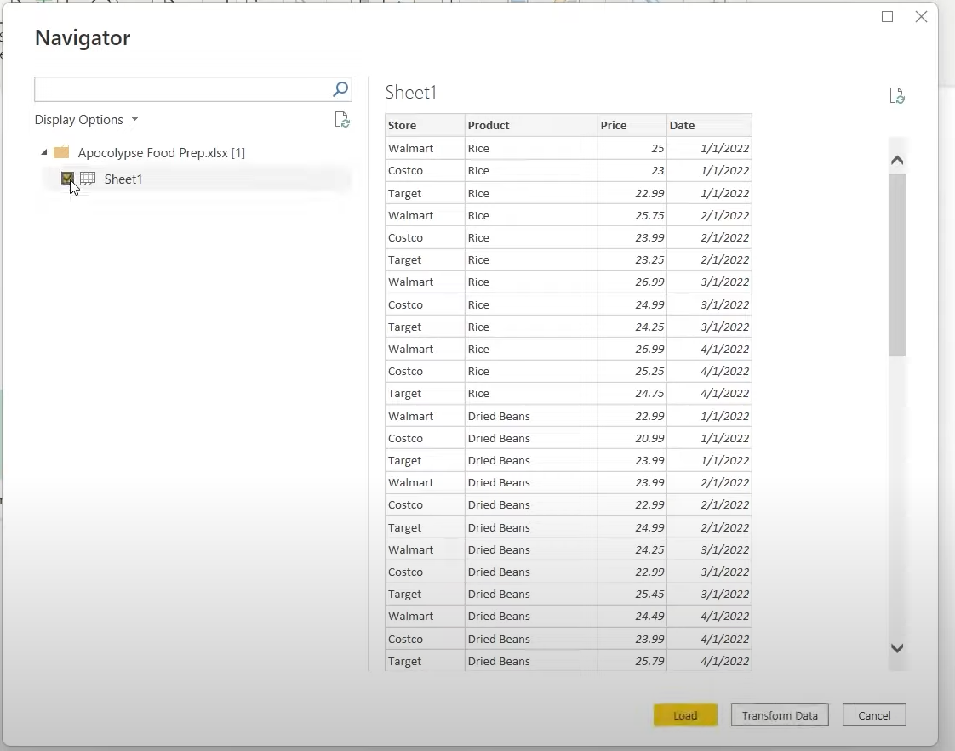

Step 2: Querying the data – Date column edited to Date_Purchased with the queried data now appearing as an audit trail in the Applied Steps table. In this case editing a column name appears as ‘Renamed Column’.

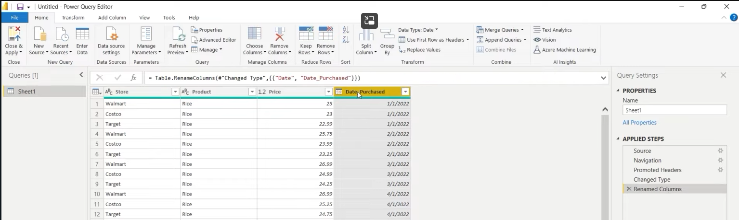

Step 2A: Querying – Milk as a product is removed as that would not survive an apocalypse scenario. This is done by using the filter function and de-selecting milk as an option. This will appear as ‘Filtered Rows’ in Applied Steps

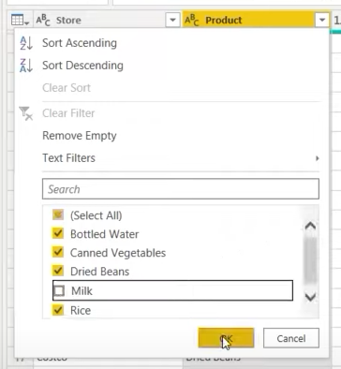

Step 3: Now the data has been cleaned we press ‘close and apply’. The data is now ready for us to build a dashboard.

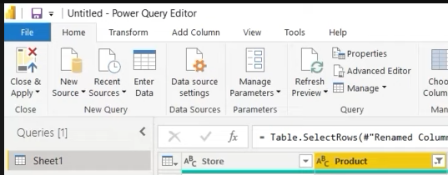

Step 4: We want to start by looking at which store offers the best price for the products listed in the table. This is done by selecting the relevant data and the table visual from the panels (shown below).

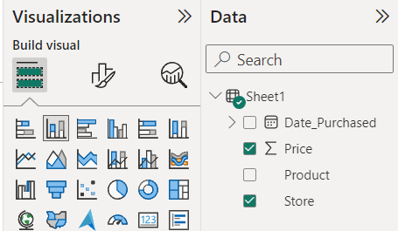

Step 5: Next we click and drag the ‘Store’ column into the legend on the Visualisations tab to add colour to the chart.

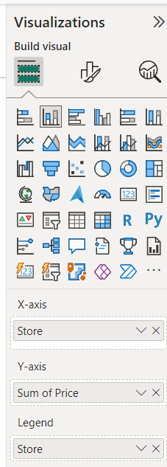 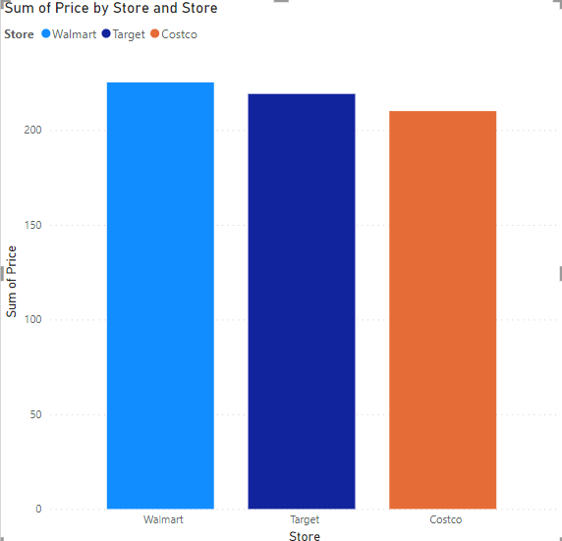

Step 5A: Next add data labels: Visualisations -> Data labels -> ‘On’

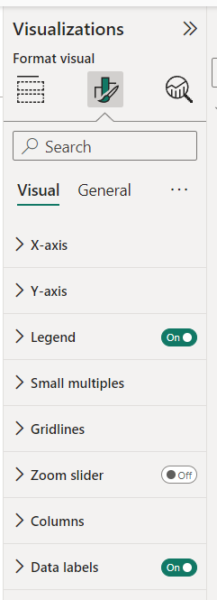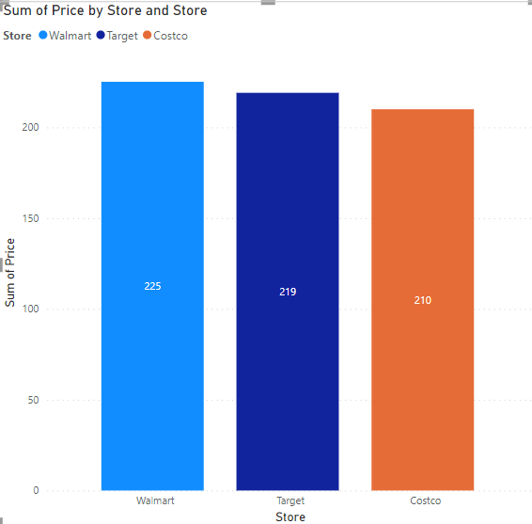

Step 6: To see how much each product would cost when compared against each store a clustered column chart is best used. We select ‘Price’ and ‘Product’ and the clustered column visual.

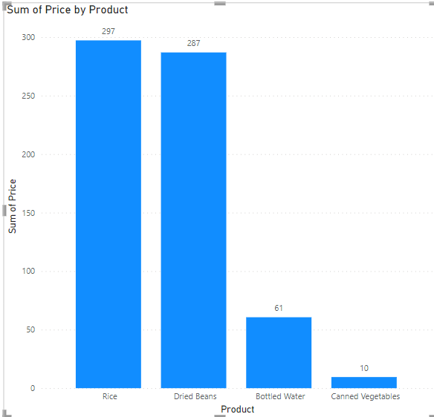

Step 6A: Click and drag ‘Store’ to the legend to break each product and its price down by store.

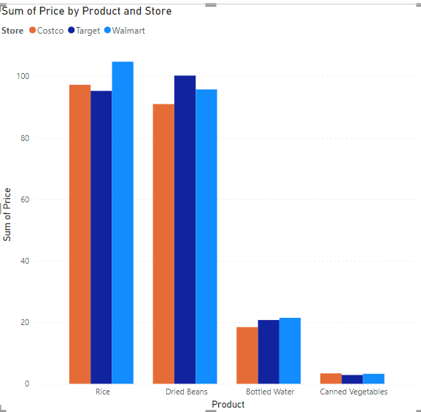

Step 6B: Adding data labels

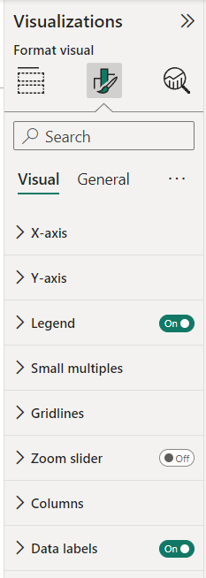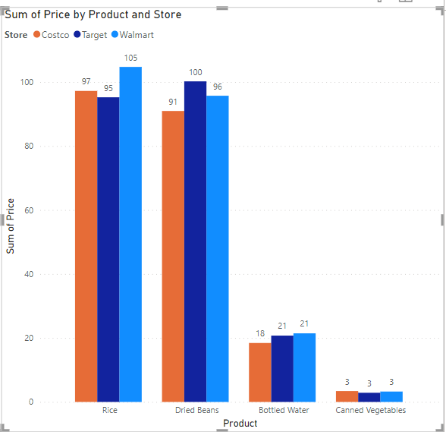

Step 7: Conclusion - It’s clear that whilst Costco is the cheapest store overall, it may be that for water and canned vegetables the quality of the product may not be as good as the others. Therefore, we can afford to shop around since the prices of the two products when compared against the other two stores are not too different (and are generally very low). However, the Rice and Dried Beans are expensive so sticking with the lowest priced product is likely the best option.

This project, including write-up took 30 minutes as a timed introduction to PowerQuery and PowerBI.